Congratulations! Your son has been selected for an MHS soccer team. This document provides an overview of important program events, resources and required actions for players and parents. Please read carefully and take action as required. Please continue to check the schedules on the MHS Boys Soccer website as changes can happen during the season.

Important Resources:
MHS Boys Soccer: www.minnetonkaboyssoccer.com |  | 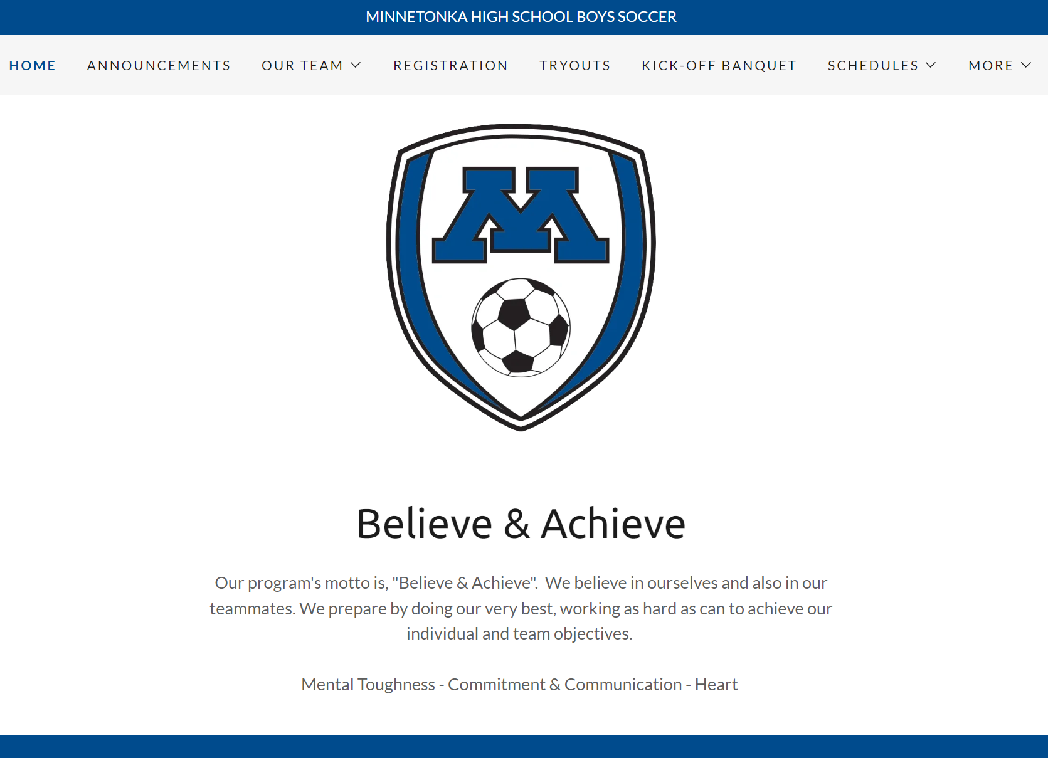
 | This is the primary website for program information during the season including team schedules, rosters and other important information. Check this regularly for schedule updates and other important information.
MHS Boys Soccer Resource Site: www.tonkafutbol.us |  | 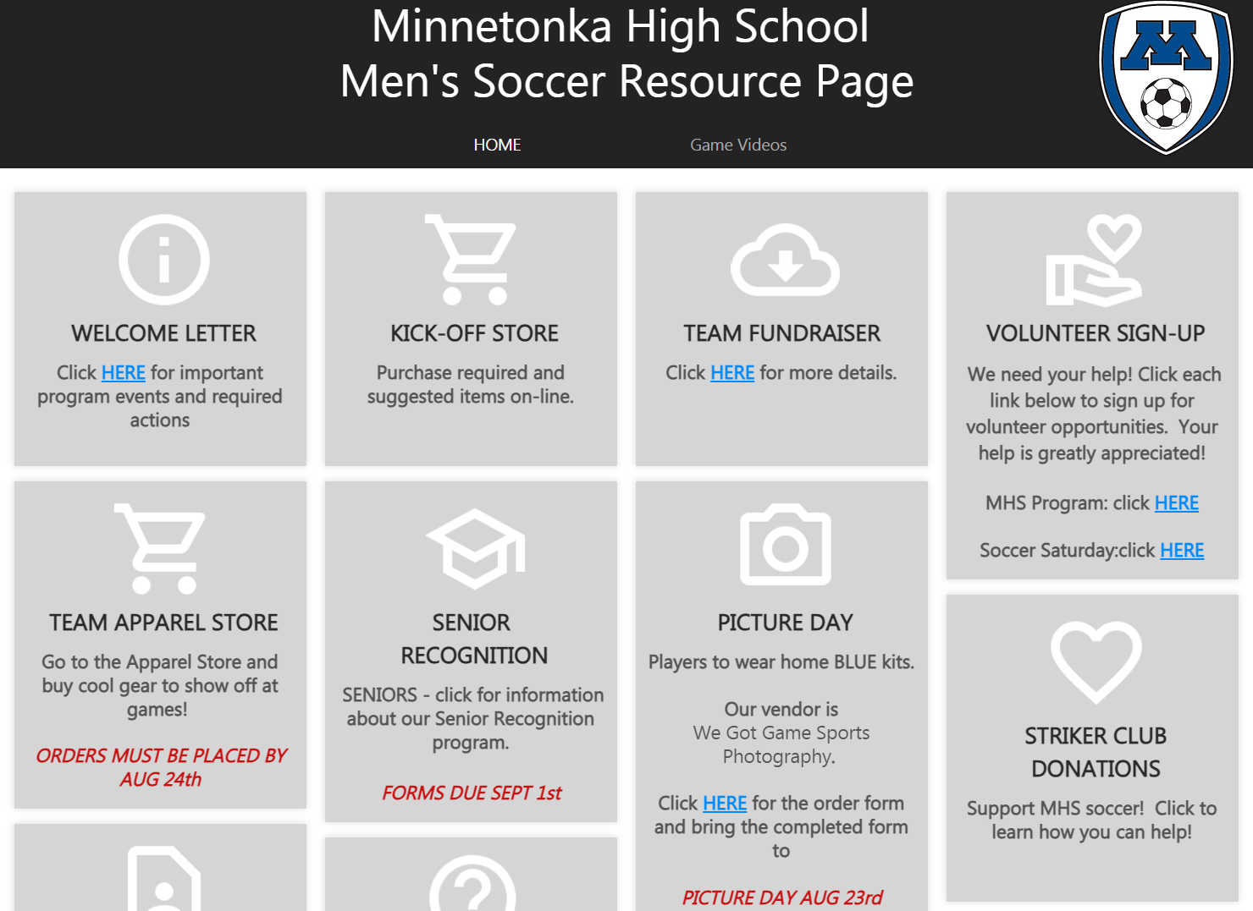
 | LIVE now! This is our online store and resource hub for all teams. Links to all checklist items (see following pages) are found here. All items can be purchased on this site. Deadline for orders is Thurs, Aug 24th - items noted ‘ASAP’ must be completed as noted.
MHS Boys Soccer Email Address: boyssoccerminnetonkahs@gmail.com
This is the program email address for general questions or information. Coaches are always the recommended best point of contact. If you are unsure of who to contact, feel free to use this email as it is regularly monitored. In addition, program-wide and some team-specific communications will come from this address.

Important Program Events:
Please add these events to your calendar and plan to participate as required.
When | What | Who | Where | Why
Tue Aug 22  5:30-7:30 pm | Mandatory Team Kick-off Event & Potluck Dinner  Fried/grilled chicken provided.  Each player is assigned to bring (enough to serve 10):  Freshman A/B: fruit/fruit salad  B-Squad: pasta salad or veggies  Varsity Reserve: dessert  Varsity: bottled water (12 pack) | ALL players and at least 1 parent or guardian for each player | MHS Cafeteria | Review MHS Athletic and Soccer program rules and expectations, meet the coaches, and learn about upcoming season plans, fundraising obligations, apparel offerings and volunteering.
Wed Aug 23  10:30 am Fr A/B  11:15 am B Squad  11:40 am VR  12:00 Varsity | Mandatory photo session for teams, individuals, and Senior Recognition | ALL players | MHS Black Box (by West Entrance) | Wear blue uniforms + bring cleats. Ordering information provided with welcome packet and at www.tonkafutbol.us We will be taking pictures at the same time for Senior Recognition.
Wed Aug 23  3:00 pm | Mandatory fundraising meeting. Watch for confirmation email on finalized time and details. | ALL players | MHS Forum | Learn about team fundraising goals and player homework expectations.
Sun Aug 27  1:45 pm (depart)  3:30 pm (kickoff) | MNUFC match vs. Seattle Sounders at 3:30pm | ALL players and coaches | Meet at MHS,  Allianz Field | Enjoy a match with your teammates at one of the best atmospheres in all of MLS, Allianz Field. Bus departs MHS at 1:45pm.
Sat Sep 23  All day | Soccer Saturday | ALL players, family, and friends | Minnetonka HS | Celebrate Minnetonka HS soccer at this all day festival, featuring matches, activities, and food.
Sat Oct 7  Noon match | Senior Recognition | ALL Seniors and their parents | Stadium & Pagel Center | Watch the Skippers vs. Chanhassen HS and, post-game, celebrate MHS’ Senior soccer players.
Sun Nov 5  6:00 pm | End-of-Season Event | ALL players and families | Medina Entertainment Center | Celebrate the season’s successes and individual awards for all the boys’ soccer teams.

*Visit www.tonkafutbol.us to complete tasks
Checklist of Required and Optional Actions: |  |  | Req’d or Optional | Where* | Due
1 | Fill out all forms
 | - Player/Parent Contact Information It is critical we receive your updated contact information of the player and parent(s) or guardian ASAP, as numerous communications will be sent immediately after tryouts and throughout the season. |  | Required | 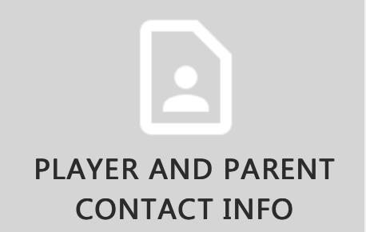 | ASAP
 | - Senior Recognition Questionnaire Seniors! We are excited to celebrate YOU and your contributions to MHS and MHS Soccer. Please fill out this questionnaire as soon as possible. |  | Required Seniors only |  | 9/1
2 | Make Purchases
 | - Socks All players, 1 pr each color |  | Required |  | 8/24
 | - Training Jersey Varsity/VR players only |  | Optional Varsity/VR only |  | 8/24
 | - Believe and Achieve T-shirts All new players to the MHS Soccer program are eligible to receive this free T-shirt. |  | Optional New players only |  | 8/24
 | - MNUFC Match vs Seattle Sounders Join your teammates at one of the best atmospheres in all of MLS, Allianz Field. Tickets are limited, so please order ASAP. |  | Optional |  | ORDER NOW
 | - Training Pullover The ‘Varsity Legend Hooded Pullover’ has been selected as the designated Varsity training pullover. Located in the ‘VARSITY Players & Coaches Only’ section. |  | Optional |  | 8/24
 | - MHS Boys Soccer Fan and Team Gear Show your team spirit! Visit the Apparel Store to purchase optional MHS Soccer fan and team gear. See ‘All Team Apparel’ and ‘Optional Parent Apparel’ sections. |  | Optional |  | 8/24
 | - Order photos Bring filled out form to Picture Day. Forms are included with the welcome packet and printable online. |  | Optional |  | 8/23

*Visit www.tonkafutbol.us to complete tasks
Checklist of Required and Optional Actions: |  |  | Req’d or Optional | Where* | Due
3 | Support MHS Soccer
 | - Online Team Fundraising Review and complete team fundraising ‘homework’ to support the continued success of MHS’ soccer programs. Top raising players will receive prizes! |  | Required
 | - Soccer Saturday Tickets Each player is expected to use/donate 10 tickets @$10 ea. You can use the tickets, sell them to family/friends, or give them away. Each ticket includes admission to all soccer games on Saturday Sep 23rd along with a meal ticket. |  | Required |  | 8/24
 | - Superfan Shirt Minimum purchase of 1 shirt per player |  | Required |  | 8/24
 | - Striker Club Contribution Make a stand alone contribution to Striker Club. |  | Optional
4 | Volunteer
 | - MHS Boys Soccer volunteer opportunities Review and sign up. In order to successfully run a program with so many players, your help is appreciated! |  | Optional |  | ASAP
 | - Soccer Saturday volunteer opportunities Review and sign up. All families are required to work a 2-hour shift. |  | Required |  | 8/28

